# Evaluation of the Existing Systems

## Evaluation Based- Site Investigations

The PMC design team carried out several site visits for all existing water distribution stations

|  |  |
| --- | --- |
|   **View of Velachery New WDS** |   **View of Velachery Old WDS** |
|   **View of Pallipattu WDS** |   **View of Pallipattu WDS** |
|   **View of Mylapore and Nandanam WDS** |   **View of Ekkattuthangal WDS** |

Figure 9 represents sample photos for the existing water pipelines captured during the site visits.

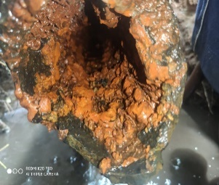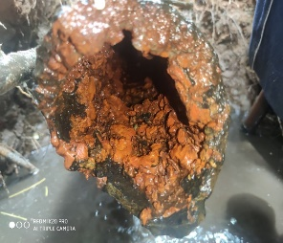

|  |  |
| --- | --- |
|   **View of Velachery New WDS** |   **View of Velachery Old WDS** |
|   **View of Pallipattu WDS** |   **View of Pallipattu WDS** |
|   **View of Mylapore and Nandanam WDS** |   **View of Ekkattuthangal WDS** |

# STRUCTURAL CONDITIONAL ASSESSMENT OF WDS

## ASSESMENT FINDINGS AS PER EXISTING WDS LOCATIONS:

### Ekkattuthangal WDS

Photographs:

|  |  |
| --- | --- |
| A picture containing outdoor, grass, sky, tree  Description automatically generated  UGT & Pumphouse | A picture containing dirty, trash  Description automatically generated  Pump Room |
| A picture containing indoor, furniture  Description automatically generated  Maintenance Bay | A picture containing indoor  Description automatically generated  Pump Room Corbel level |

### 

### Velachery New WDS

Photographs:

|  |  |
| --- | --- |
| A picture containing grass, outdoor, tree, field  Description automatically generatedGround Level Reservoir  A picture containing indoor, dirty  Description automatically generated  Pump Room | A picture containing indoor  Description automatically generated  Pumping Station |

### Velachery Old WDS

|  |  |
| --- | --- |
| A picture containing text, outdoor, tree, sign  Description automatically generated  Pumping Station | A picture containing text, grass, outdoor, old  Description automatically generated  Ground Level Reservoir |
| A picture containing indoor, ceiling  Description automatically generated  Pump Room | A picture containing outdoor, curb  Description automatically generated  Chlorine Building |
| A picture containing indoor  Description automatically generated  Leakage on Pump room Ceiling | Exhaust vent damaged  A picture containing building, window, painting, painted  Description automatically generated  Window glass panel damaged |

### Pallipattu WDS

Photographs:

|  |  |
| --- | --- |
| A picture containing grass, tree, outdoor  Description automatically generatedUGT  A picture containing indoor, ceiling, floor, blue  Description automatically generated  Pump Room | A picture containing indoor, building, dirty, old  Description automatically generated  Chlorine Room |
| A picture containing dirty  Description automatically generatedDiagonal Crack above Corbel  A picture containing indoor, ceiling, wall, several  Description automatically generated  Damp patches on Wall | A picture containing indoor, ceiling  Description automatically generated  Roof Leakage and Damp patches on Wall  A picture containing old, dirty  Description automatically generated  Damaged MS Platform |
| A building under construction  Description automatically generated with low confidenceOverhead Tank  A picture containing building, stone  Description automatically generatedConcrete Spalling at bottom of OHT Floor | A picture containing text, tree, outdoor  Description automatically generated  Damaged Staircase |

### Mylapore & Nandanam WDS: .

|  |  |
| --- | --- |
| A picture containing grass, outdoor, field  Description automatically generatedUGT  A building with trees in front of it  Description automatically generated with low confidence  Pumping Station  A picture containing indoor, several  Description automatically generated  Pump Room | A picture containing yellow, porch  Description automatically generatedChlorine Room |

### Thiruvanmiyur WDS:

|  |  |
| --- | --- |
| A group of people walking out of a building  Description automatically generated with medium confidence  Pumping Station  A picture containing outdoor, building, wooden  Description automatically generated  OHT not in use | A picture containing indoor, ceiling, several, dirty  Description automatically generated  Pump room |
| A picture containing grass, outdoor, old, dirt  Description automatically generated  UGT | A picture containing grass, outdoor, ground, old  Description automatically generatedNo Chlorine Room |

# CHAPTER 12: SOCIAL SAFEGAURD SITUATION REVIEW & IMPACT ANALYSIS

## Ground Situations of Water Supply and Its Satisfaction

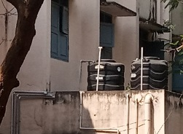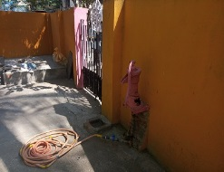

#### Figure 71 Multiple Sources to Access Potable Water

# CHAPTER 14: ELECTRICAL WORKS

## Electrical Conditional Assessment

## Ekkattuthangal WDS:

|  |  |
| --- | --- |
| A picture containing floor, indoor, furniture, dirty  Description automatically generated  400 kVA Transformer | A picture containing device, miller  Description automatically generated  DG Set |
| A row of blue lockers  Description automatically generated with low confidence  LV Switchboard | A picture containing outdoor, dirty  Description automatically generated  LV Motor |
| A picture containing text, indoor  Description automatically generated  Capacitor Banks | A picture containing indoor, dirty  Description automatically generated  LDBs & DB |
| A picture containing indoor, dirty, area  Description automatically generated  Manual Valves & Pump Set | A picture containing indoor, floor  Description automatically generated  EOT Crane |

## Velachery New WDS

|  |  |
| --- | --- |
| A picture containing indoor, old, dirty, cluttered  Description automatically generated  LV Motors & MOVs | A picture containing text, green  Description automatically generated  DG Set |
| A picture containing indoor, wall, dirty  Description automatically generated  EOT Crane | A picture containing text, floor, indoor  Description automatically generated  ATS Starters |
| A picture containing furniture, cabinet, indoor, chest of drawers  Description automatically generated  Capacitor Panel | A picture containing text, furniture, cabinet  Description automatically generated  LV Switchboard |
| A picture containing outdoor, sky, grass  Description automatically generated  4-pole structure & Transformers |  |
| A picture containing text, white, dirty  Description automatically generated  LDBs & DB |

## Velachery Old WDS

|  |  |
| --- | --- |
| A picture containing floor, furniture  Description automatically generated  630 kVA Transformer | A picture containing text, white, device, miller  Description automatically generated  11 KV Switchboard |
| A picture containing cabinet, furniture  Description automatically generated  LV Switchboard | A picture containing text, indoor, dirty, old  Description automatically generated  MOV Starter Panel & LPBS |
| IMG_20210909_120905  400 kVA DG Set | A picture containing ground, dirty, old, broken  Description automatically generated  Chlorination Gas blower |
| A picture containing outdoor, old, dirty, equipment  Description automatically generated  VT Motor | EOT Crane |

## Pallipattu WDS

|  |  |
| --- | --- |
| Transformer | A picture containing old, furniture, stone, trash  Description automatically generated  VT Motors |
| A picture containing indoor, ceiling, equipment  Description automatically generated  EOT Crane | A picture containing text, device, miller  Description automatically generated  MOV Starter & LPBS |
| A picture containing floor, indoor  Description automatically generated  PMCC Panel | A picture containing indoor, cabinet  Description automatically generated  APFC Panel |
| Cable Carrier System | A picture containing device, engine, miller  Description automatically generated  DG Set |

## Mylapore-Nandanam WDS

|  |  |
| --- | --- |
| A picture containing miller  Description automatically generated  2 MVA Transformer | A picture containing floor, indoor  Description automatically generated  Cable Carrier System |
| A picture containing indoor, floor, room, furniture  Description automatically generated  VT Motors | A picture containing ground  Description automatically generated  MOVs |
| A picture containing text, cabinet, furniture  Description automatically generated  PMCC Panel | A row of white lockers  Description automatically generated with low confidence  ATS Starter panel |
| A picture containing text, cabinet, furniture  Description automatically generated  Capacitor Panel | A picture containing device  Description automatically generated  LPBS |
| A picture containing indoor  Description automatically generated  EOT Crane | A picture containing indoor, device, furniture, cluttered  Description automatically generated  DG Set |

## Thiruvanmiyur WDS

|  |  |
| --- | --- |
| A picture containing sky, outdoor object  Description automatically generated  4-Pole Structure | A picture containing tree  Description automatically generated  Transformer  A picture containing indoor, engine, dirty, miller  Description automatically generated  MOV & Pump-Motor Sets |
| A picture containing furniture, indoor, cabinet, wardrobe  Description automatically generated  Capacitor Panel | A row of green lockers  Description automatically generated with low confidence  DG Set |
| A picture containing indoor  Description automatically generated  PMCC Panel | A picture containing text  Description automatically generated  ATS Starters |

# MECHANICAL CONDITIONAL ASSESSMENT

The PMC design team conducted several site visits for all WDS within zone XIII. The following sections shall provide the detailed findings for each WDS.

## Ekkattuthangal WDS (date of visit 08.09.2021):

## Velachery New WDS (date of visit 09.09.2021):

## Velachery Old WDS (date of visit 09.09.2021):

## Pallipattu WDS (date of visit 09.09.2021):

## Thiruvanmaiyur WDS (date of visit 09.09.2021):

# INSTRUMENTATION & CONTROL CONDITIONAL ASSESSMENT

## Ekkattuthangal WDS

**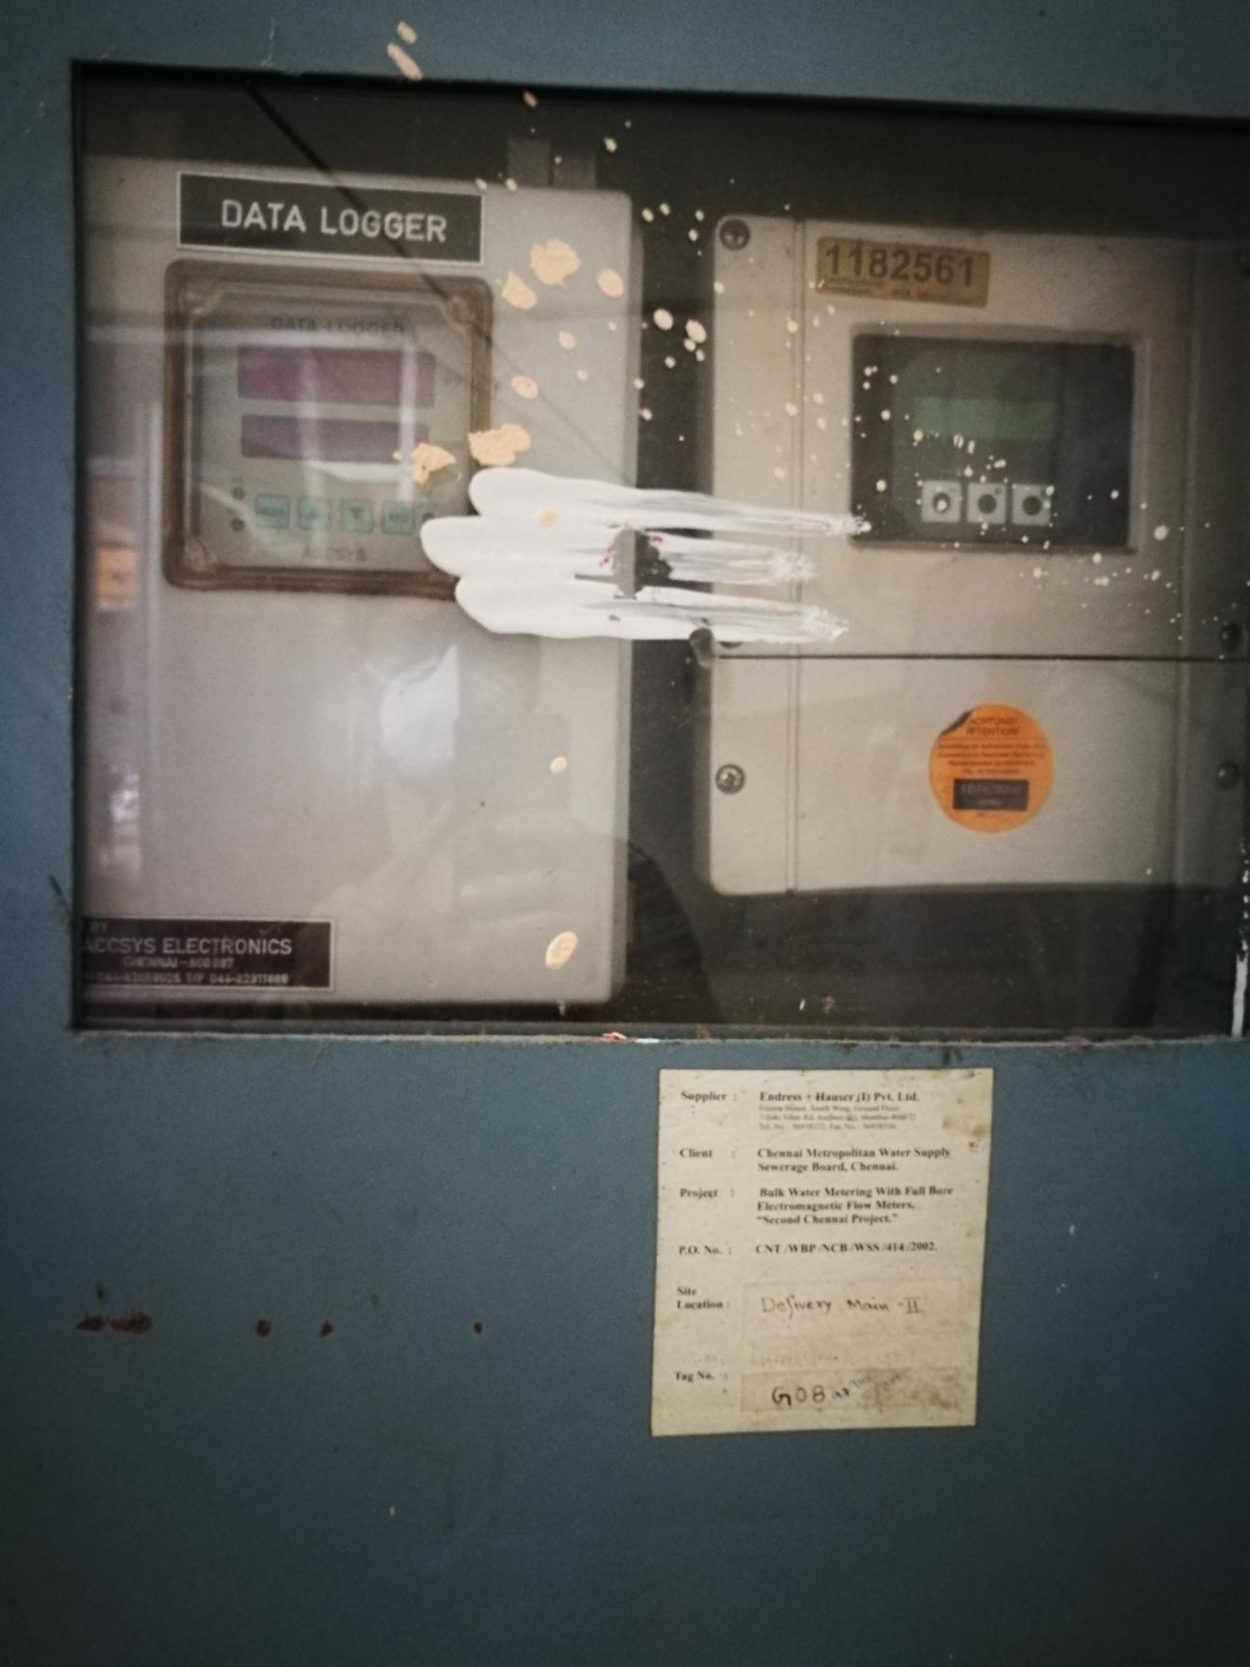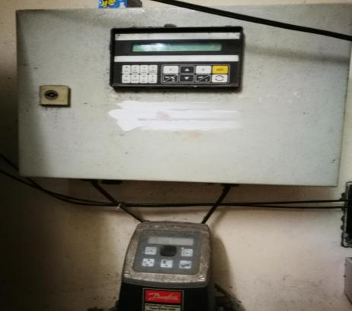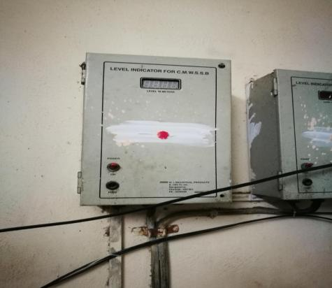** **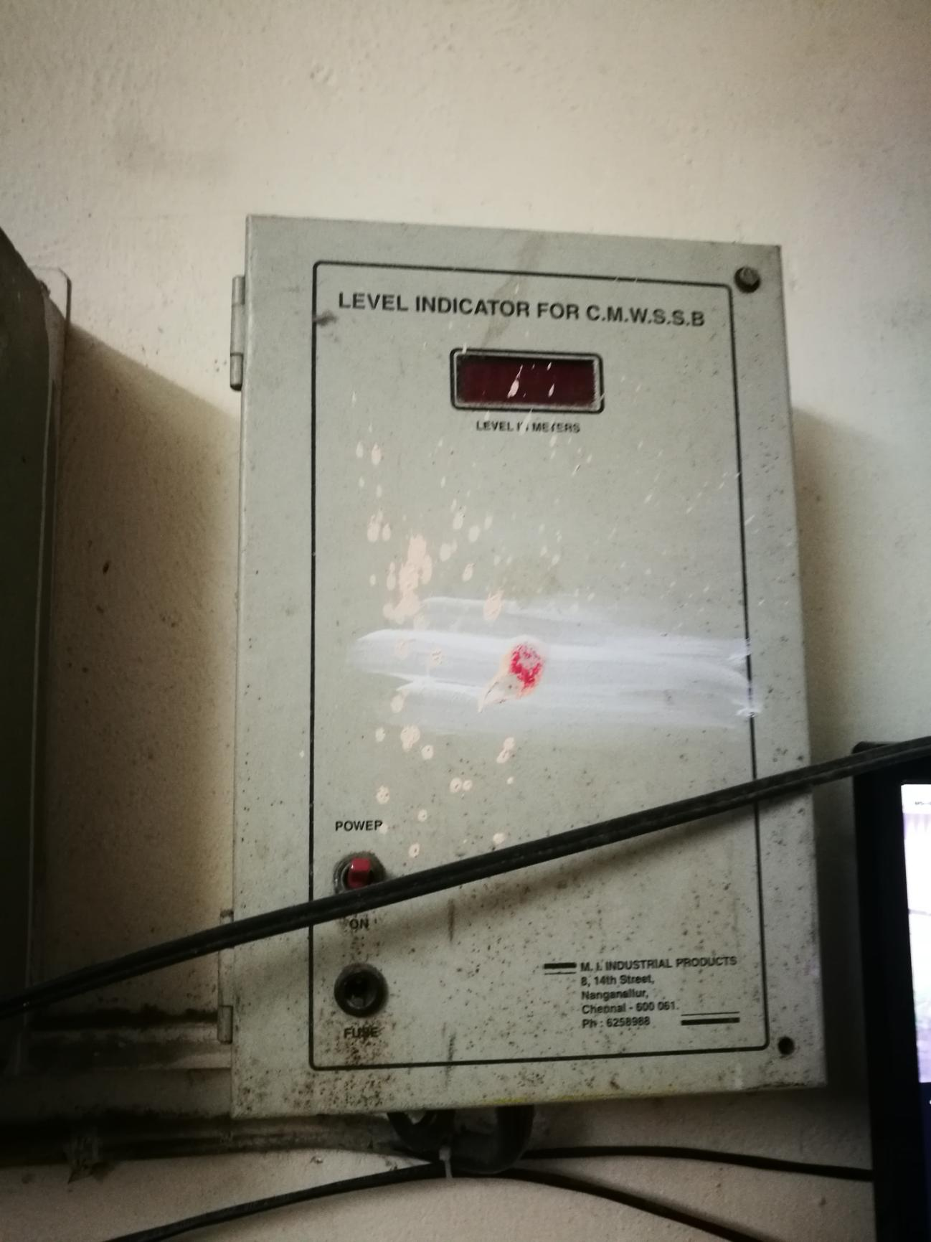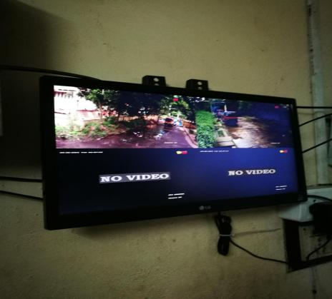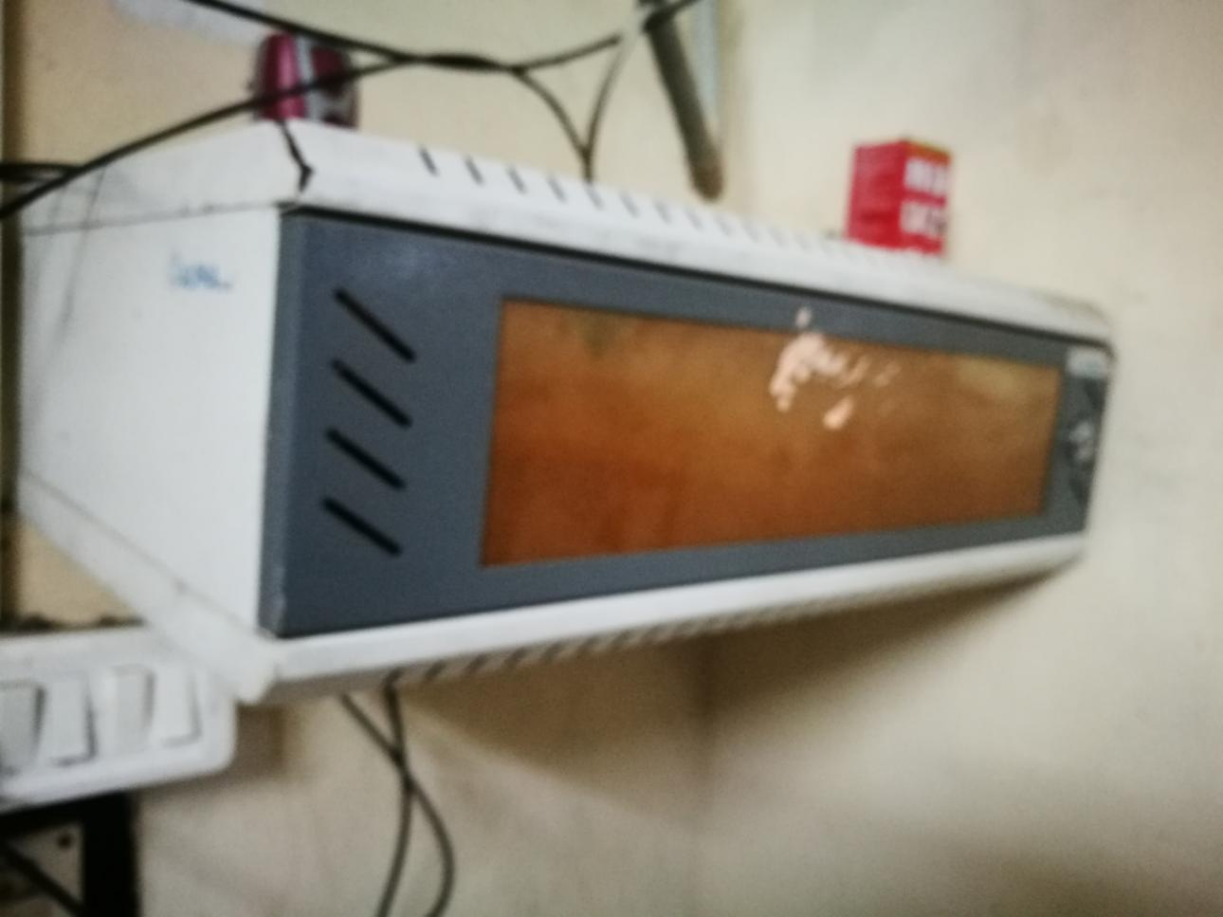**

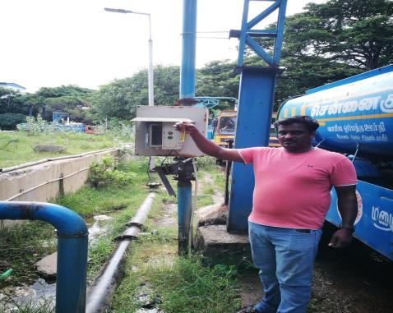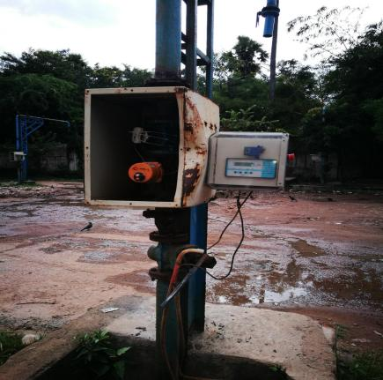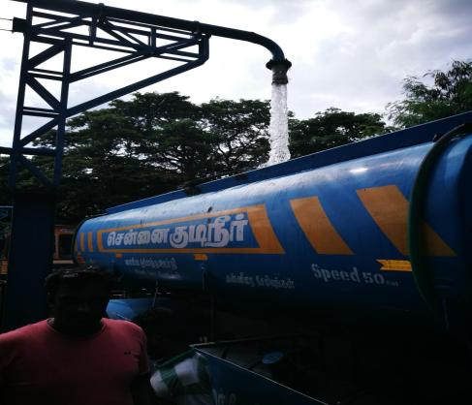

## Velachery Old WDS

**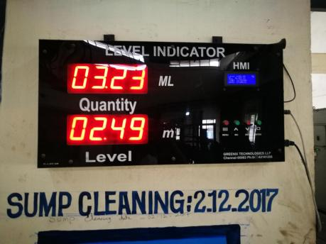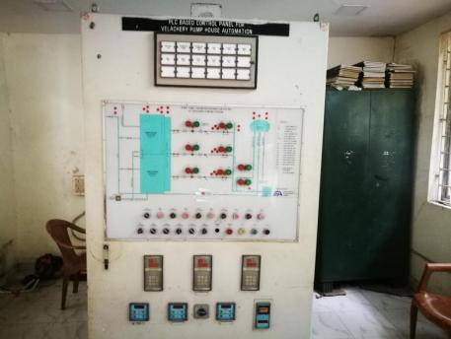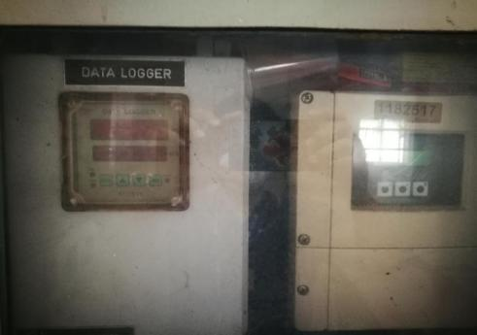**

**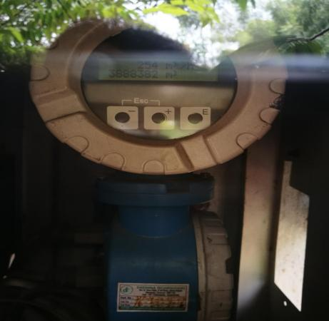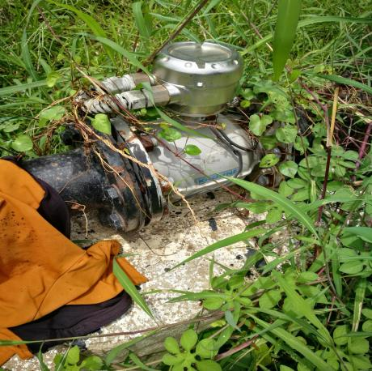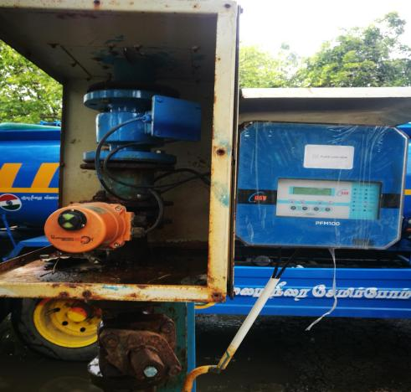**

**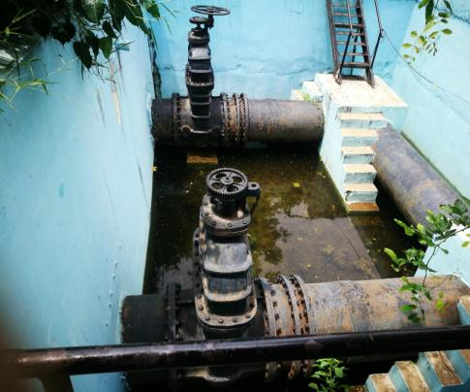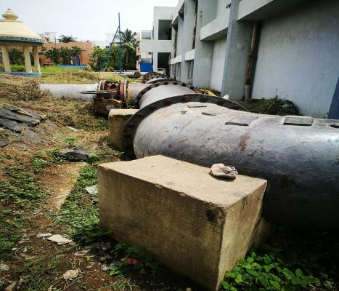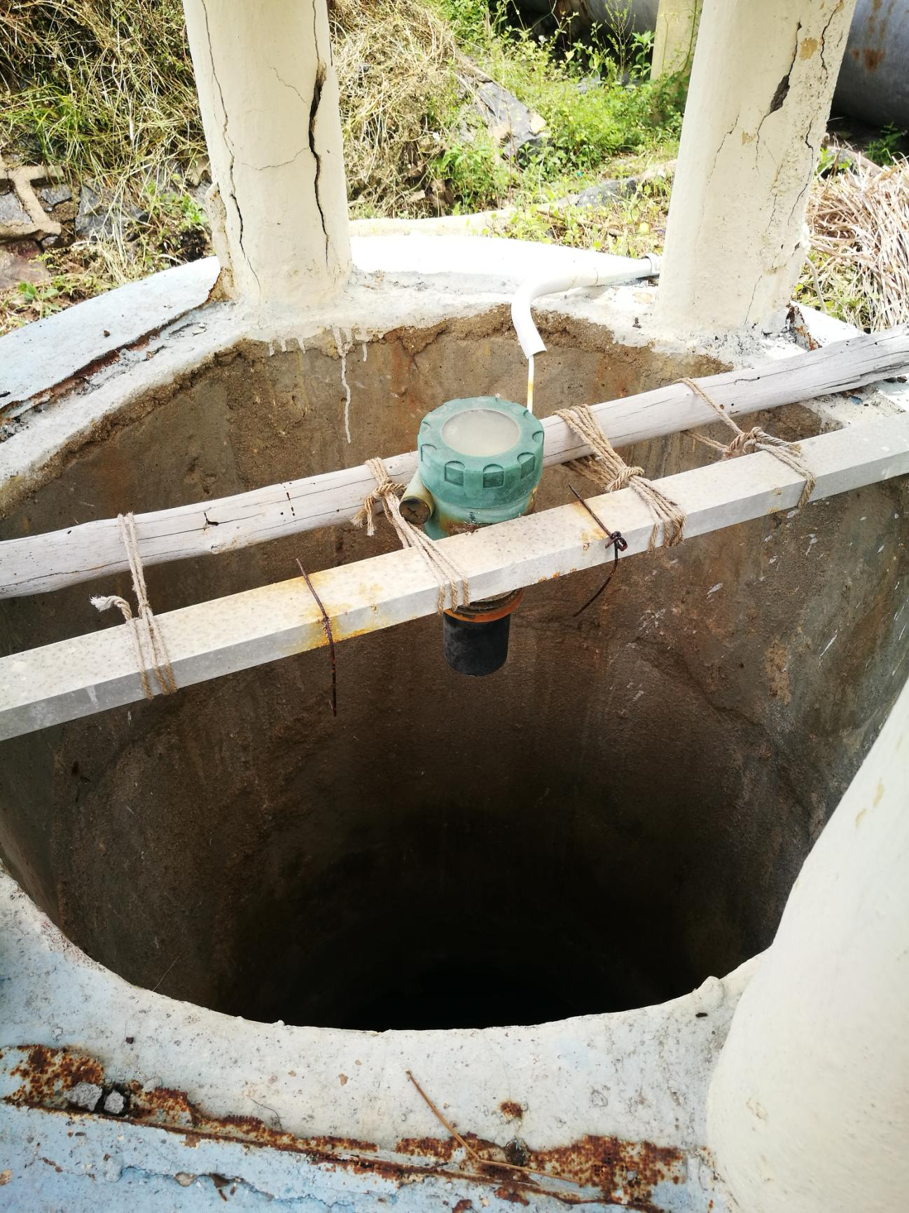**

**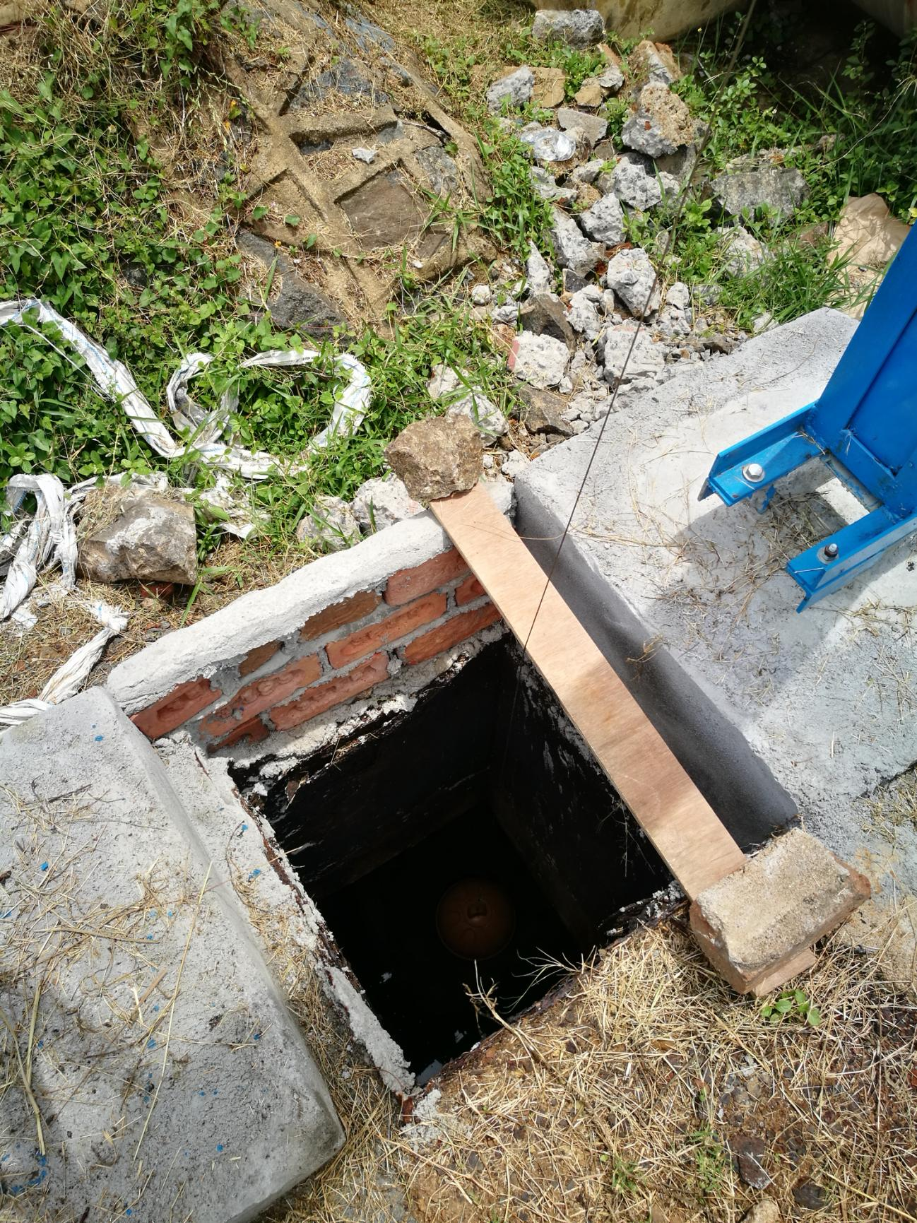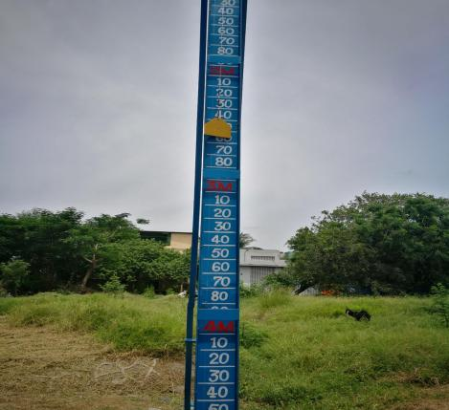**

## Velachery New WDS

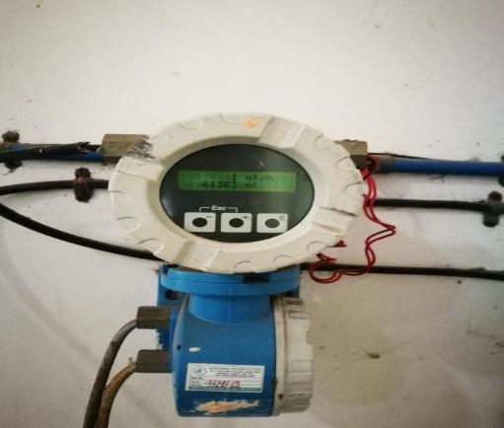 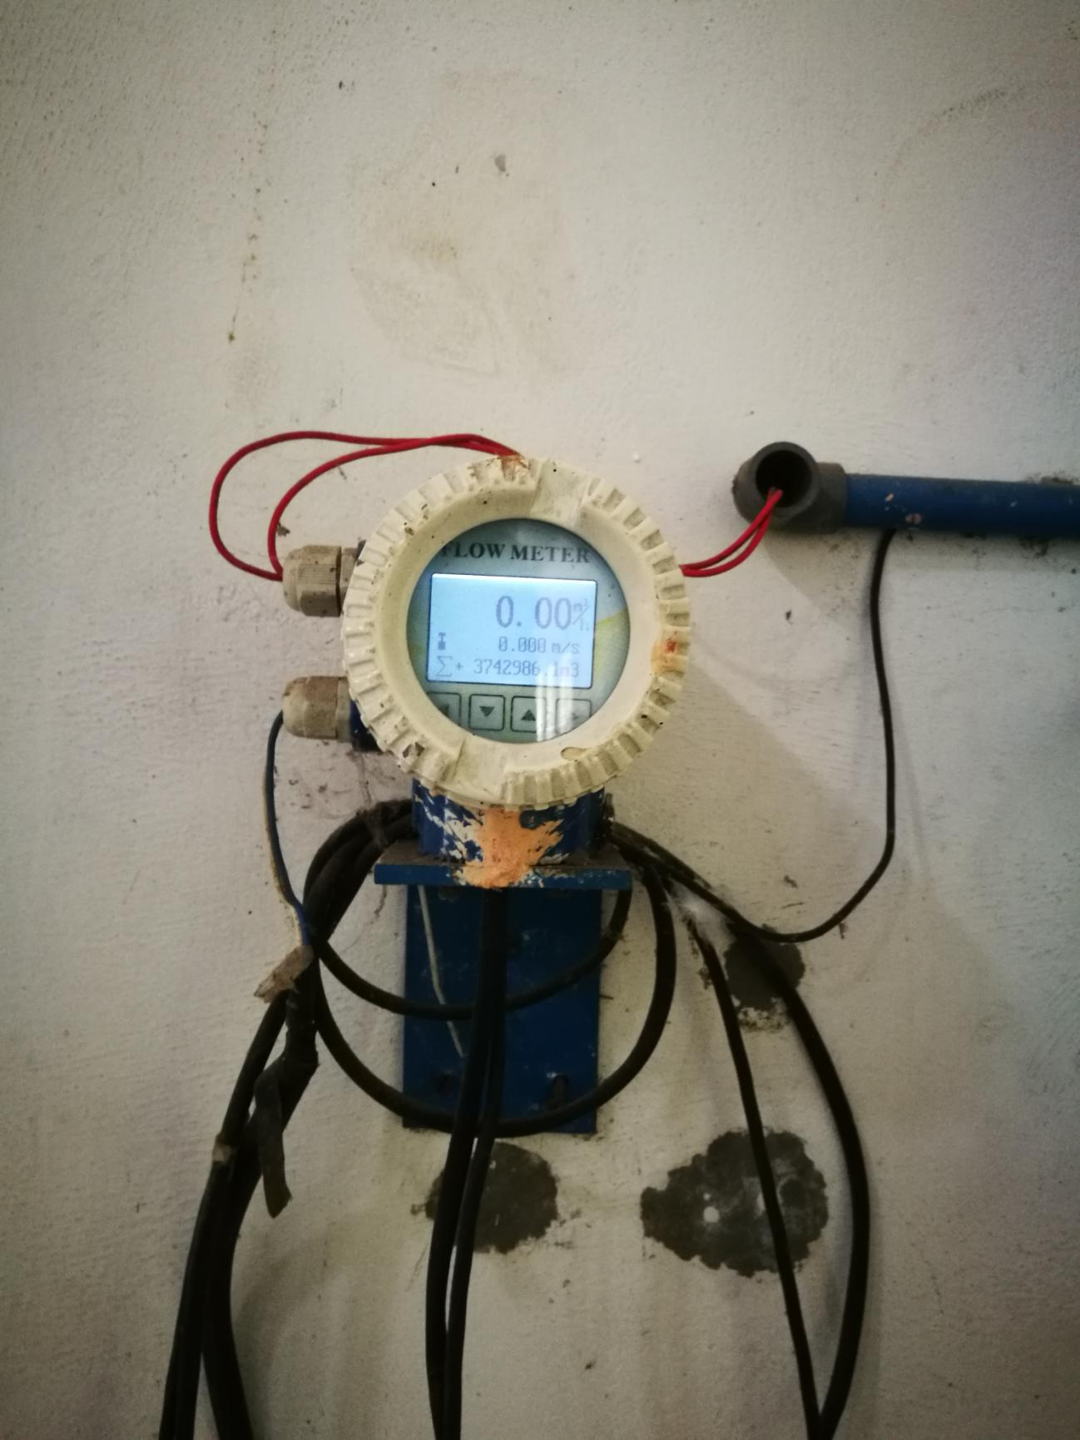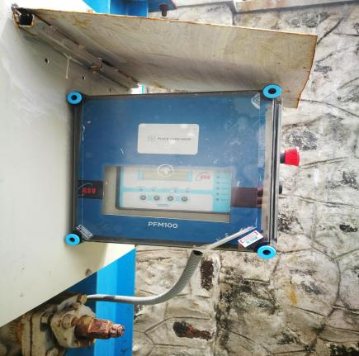

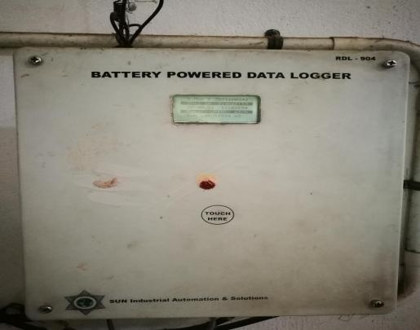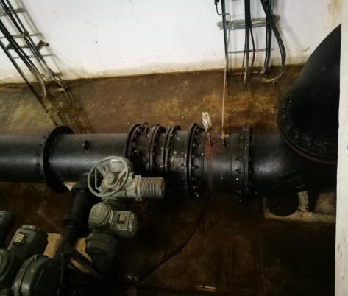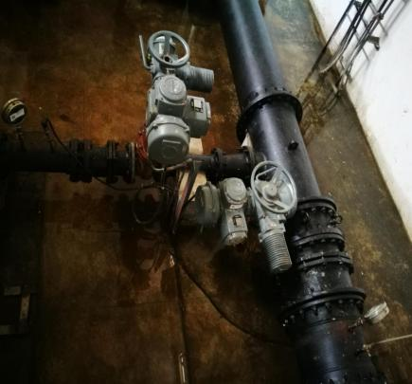

**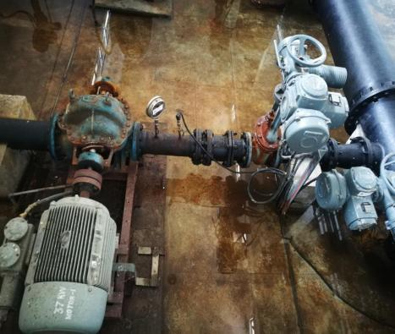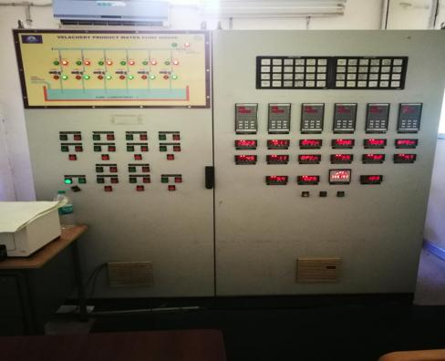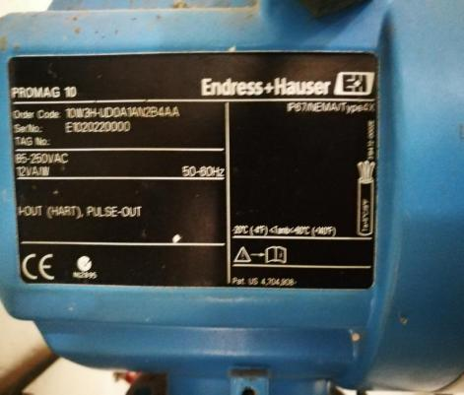**

## Pallippattu WDS

**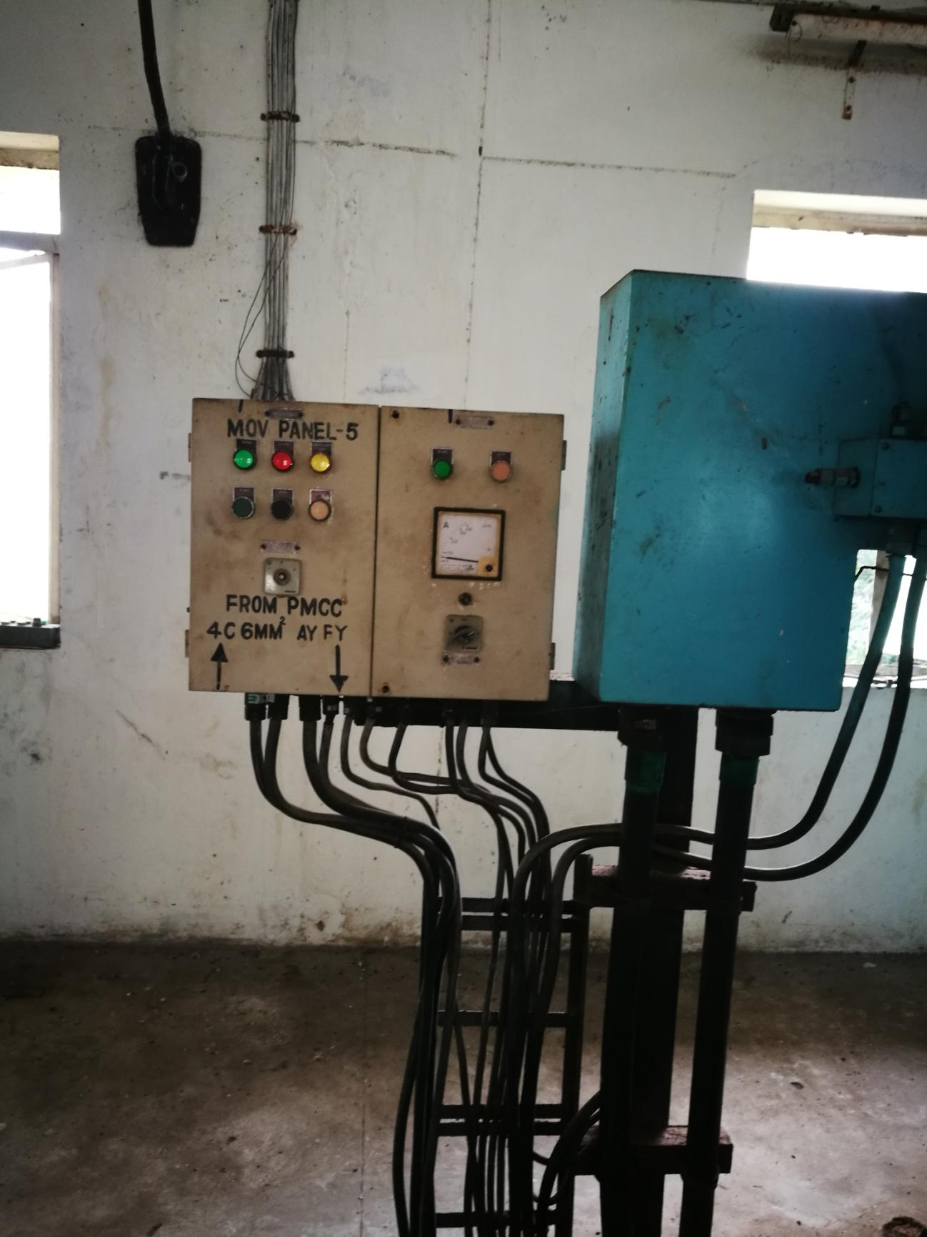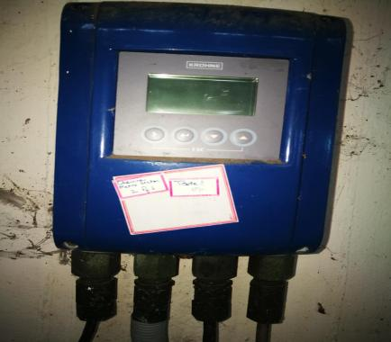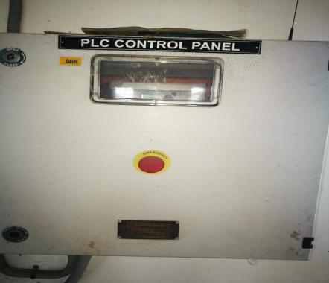** **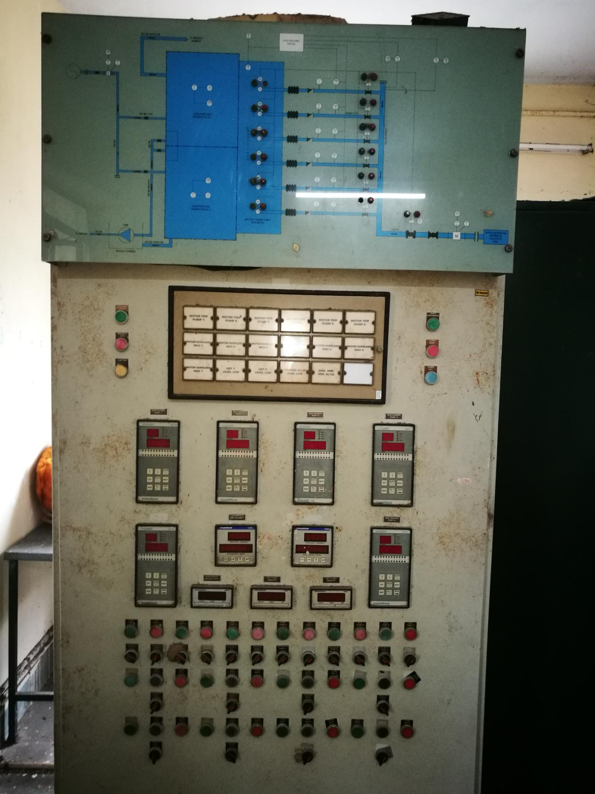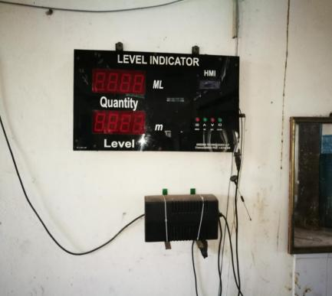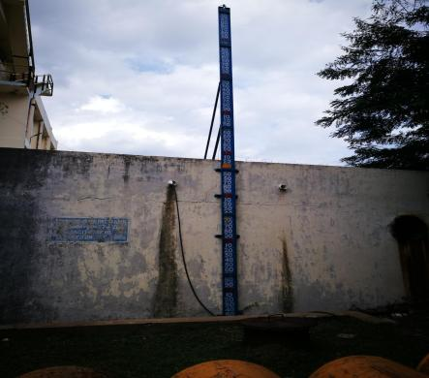**

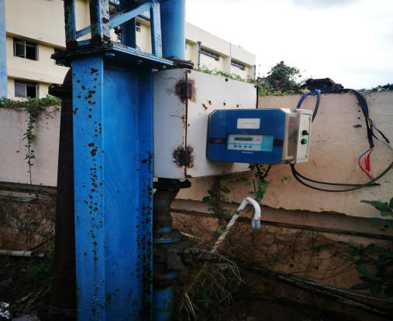

Thirumanmaiyur WDS

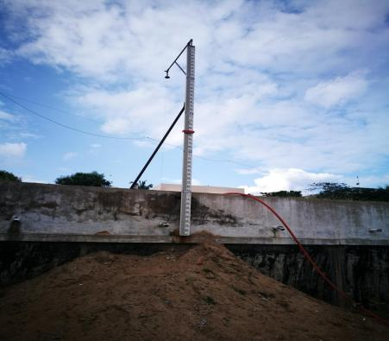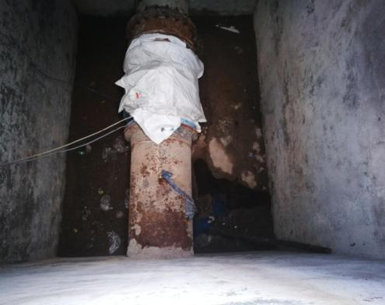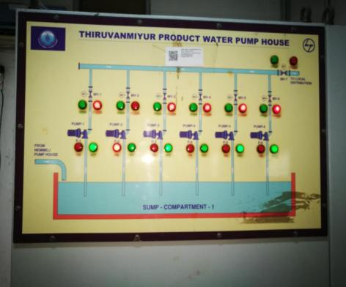

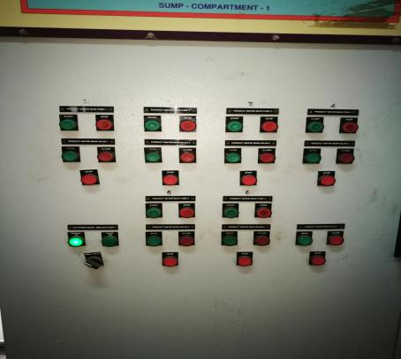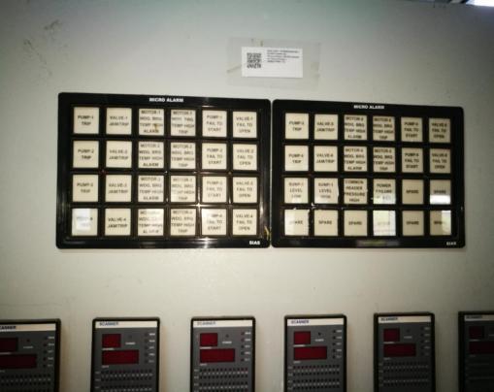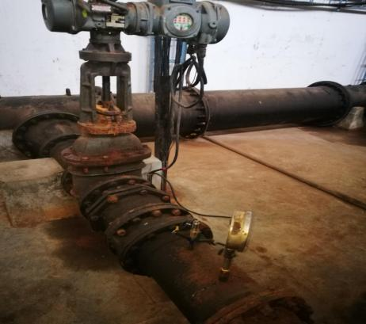

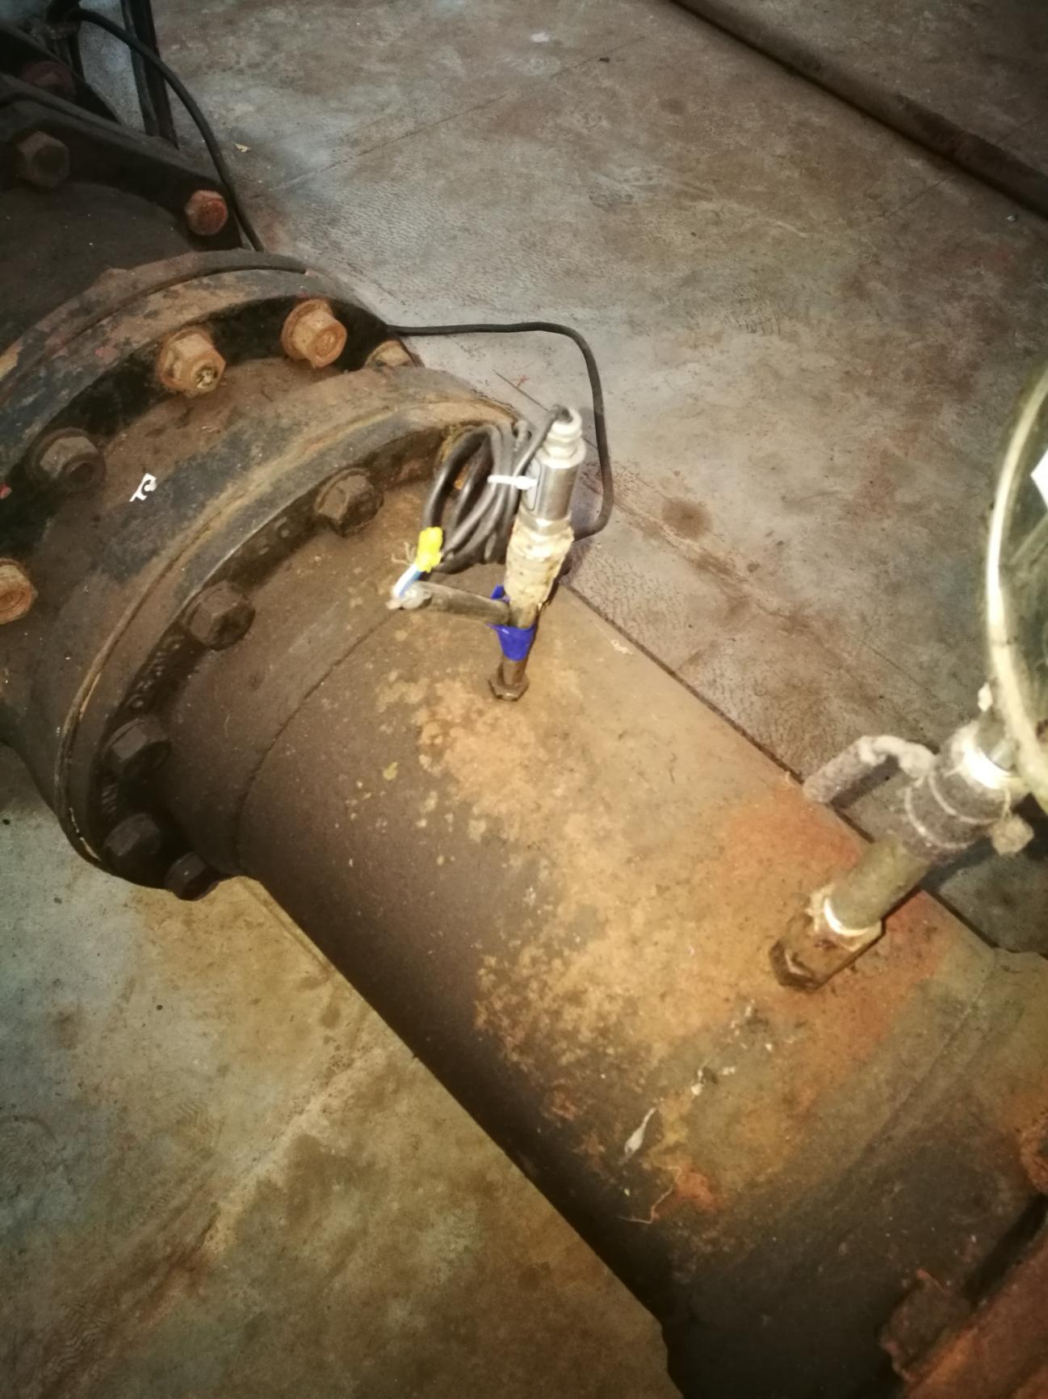 **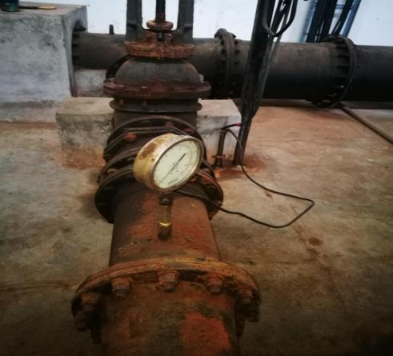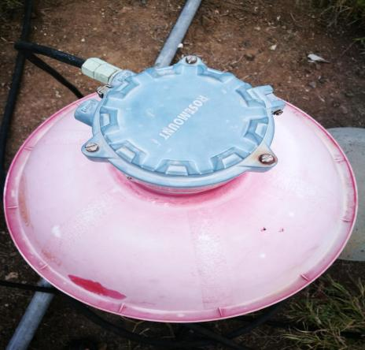**

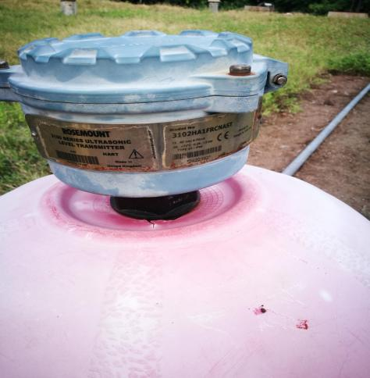

**Mylapore and Nandanam WDS**

**

